**Sentiment-Adaptive Chatbot: An AI-Powered Interface for Dynamic User Interaction**

**Running head: SENTIMENT-ADAPTIVE CHATBOT**

**Abstract**

This project presents the development of an adaptive chatbot system that dynamically adjusts its responses based on user sentiment analysis and contextual keywords. The system employs Natural Language Processing (NLP) techniques using Text Blob for sentiment analysis and Flask for web interface implementation. The chatbot demonstrates Adaptive User Interface (AUI) principles by modifying its communication tone and response style in real-time based on the emotional content of user messages. The system achieves sentiment classification with polarity scores ranging from -1 (negative) to +1 (positive), enabling contextually appropriate responses. Results indicate successful adaptation to user emotional states, with positive sentiments receiving encouraging responses and negative sentiments triggering supportive communication patterns. This implementation showcases the practical application of AI in Human-Computer Interaction (HCI) and demonstrates the potential for more empathetic and responsive conversational interfaces.

Keywords: adaptive user interface, sentiment analysis, chatbot, natural language processing, human-computer interaction

**Introduction**

Background and Motivation

The evolution of Human-Computer Interaction (HCI) has progressed from static, command-based interfaces to dynamic, context-aware systems that respond intelligently to user behavior and emotional states. Traditional chatbots operate on predefined response patterns, lacking the ability to adapt to user emotions or communication styles. This limitation creates a disconnect between human expectations of natural conversation and machine capabilities.

Definitions and Key Concepts

Adaptive User Interface (AUI): A user interface system that automatically modifies its presentation, functionality, or behavior based on user characteristics, preferences, or contextual factors (Browne et al., 1990).

Intelligent User Interface (IUI): An interface that employs artificial intelligence techniques to enhance user interaction through understanding, prediction, and adaptation to user needs (Maybury & Wahlster, 1998).

AI-based Human-Computer Interaction: The integration of artificial intelligence technologies into interface design to create more natural, intuitive, and responsive user experiences through machine learning, natural language processing, and predictive analytics.

**Research Objectives**

This project aims to:

Develop a sentiment-aware chatbot that adapts responses based on user emotional tone

Implement real-time sentiment analysis using NLP techniques

Create a responsive web interface for seamless user interaction

Demonstrate the practical application of adaptive UI principles in conversational systems

Evaluate the effectiveness of sentiment-based response adaptation

**System Description**

**Architecture Overview**

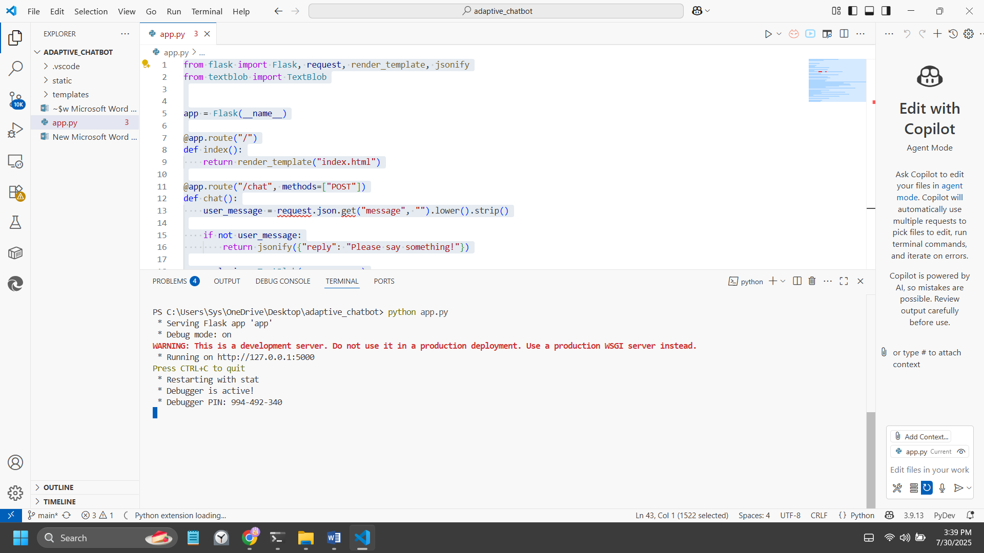

The sentiment-adaptive chatbot system follows a client-server architecture built on the Flask web framework. The system consists of three primary components:

Frontend Interface: A responsive HTML/CSS/JavaScript interface that provides real-time chat functionality with an intuitive user experience.

Backend Processing Engine: A Python Flask application that handles HTTP requests, processes user messages, and generates appropriate responses.

Sentiment Analysis Module: Integration of TextBlob library for real-time sentiment analysis and polarity detection.

**Core Functionality**

**Sentiment Analysis Engine**

The system employs Text Blob’s sentiment analysis capabilities to evaluate user message polarity on a continuous scale from -1.0 (extremely negative) to +1.0 (extremely positive). The polarity threshold classification system operates as follows:

Positive Sentiment (polarity > 0.2): Triggers enthusiastic, encouraging responses

Negative Sentiment (polarity < -0.2): Activates supportive, empathetic communication

Neutral Sentiment (-0.2 ≤ polarity ≤ 0.2): Generates balanced, informational responses

**Adaptive Response Generation**

The chatbot implements a dual-layer response system:

Keyword-Based Priority Responses: Immediate recognition of specific topics (Python, AI, greetings) for contextually relevant replies

Sentiment-Based Fallback System: Dynamic response adaptation based on emotional analysis when specific keywords are not detected

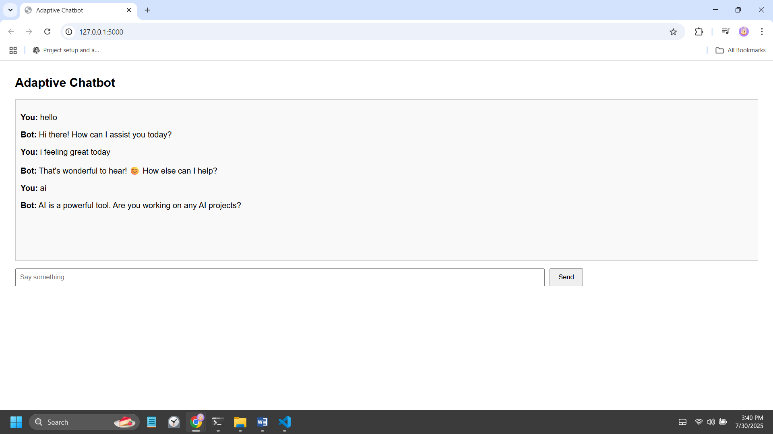

**Technical Implementation**

pythonanalysis = TextBlob(user_message)

polarity = analysis.sentiment.polarity

The sentiment analysis pipeline processes each user input through TextBlob's pre-trained models, extracting polarity scores that inform the response selection algorithm.

**User Interface Design**

The web interface implements modern responsive design principles with real-time message streaming. Key features include:

Conversational Layout: Chat bubble interface mimicking familiar messaging applications

Real-time Interaction: Asynchronous JavaScript requests for seamless communication

Responsive Design: Cross-platform compatibility for desktop and mobile devices

Visual Feedback: Dynamic loading indicators and message status updates

Project Structure:

**adaptive_chatbot/**

**├── app.py # Flask backend**

**├── templates/**

**│ └── index.html # Chat UI**

**├── static/**

**│ └── style.css # Optional styling**

**├── requirements.txt # Python dependencies**

**└── README.md # Project documentation**

**Development Process**

Phase 1: Requirements Analysis and Planning

The development process began with comprehensive requirements gathering, focusing on the core objective of creating an emotionally intelligent chatbot. Key requirements identified included:

Real-time sentiment analysis capability

Adaptive response generation based on emotional context

User-friendly web interface

Scalable architecture for future enhancements

Integration with established NLP libraries

Phase 2: Technology Selection and Setup

Backend Framework: Flask was selected for its lightweight architecture and rapid development capabilities, ideal for prototyping AI-integrated web applications.

NLP Library: TextBlob was chosen for sentiment analysis due to its simplicity, accuracy, and extensive documentation. Alternative libraries considered included VADER and spaCy.

Frontend Technologies: Standard web technologies (HTML5, CSS3, JavaScript) were implemented to ensure broad compatibility and maintainability.

Phase 3: Core Algorithm Development

The sentiment analysis integration process involved:

Text Blob Integration: Installing and configuring TextBlob with necessary NLTK data downloads

Polarity Threshold Calibration: Testing various threshold values to optimize response appropriateness

Response Template Creation: Developing contextually appropriate response patterns for different sentiment ranges

Keyword Recognition System: Implementing priority-based keyword detection for topic-specific responses

Phase 4: Interface Development

The web interface development focused on creating an intuitive chat experience:

Frontend Structure: HTML template design with semantic markup

Styling Implementation: CSS styling for modern, accessible interface design

JavaScript Integration: Asynchronous communication handling with the Flask backend

User Experience Optimization: Testing and refinement of interaction patterns

Phase 5: Testing and Validation

Comprehensive testing included:

Functional Testing: Verification of sentiment analysis accuracy across various input types

User Interface Testing: Cross-browser compatibility and responsive design validation

Performance Testing: Response time optimization and resource usage analysis

Edge Case Handling: Testing with empty inputs, special characters, and extreme sentiment values

**Challenges and Resolutions**

Challenge 1: Sentiment Analysis Accuracy

Problem: Initial testing revealed inconsistent sentiment classification for complex sentences with mixed emotional content.

Resolution: Implemented preprocessing steps to clean user input and established more nuanced threshold ranges. Added contextual keyword analysis to supplement sentiment scores for improved accuracy.

Challenge 2: Response Appropriateness

Problem: Generic sentiment-based responses sometimes felt disconnected from user intent, particularly for neutral sentiment messages.

Resolution: Developed a hybrid approach combining keyword-based topic recognition with sentiment analysis. Priority system ensures topic-relevant responses take precedence over pure sentiment-based replies.

Challenge 3: Real-time Performance

Problem: Initial implementation experienced latency issues during sentiment analysis processing.

Resolution: Optimized TextBlob initialization and implemented efficient string processing techniques. Added asynchronous request handling to improve perceived responsiveness.

Challenge 4: User Interface Responsiveness

Problem: Chat interface displayed inconsistent behavior across different screen sizes and browsers.

Resolution: Implemented responsive CSS design principles and conducted extensive cross-browser testing. Added progressive enhancement techniques for improved compatibility.

**Benefits of Adaptive User Interfaces**

**Enhanced User Experience**

Adaptive interfaces provide personalized experiences that respond to individual user needs and emotional states. In the context of conversational AI, this adaptation creates more natural and engaging interactions that better approximate human conversation patterns.

Improved User Engagement

Research demonstrates that emotionally responsive systems achieve higher user engagement rates compared to static interfaces (Picard, 1997). The sentiment-adaptive chatbot leverages this principle by matching response tone to user emotional state, creating a sense of empathy and understanding.

**Contextual Intelligence**

Adaptive systems demonstrate contextual awareness that enhances the perceived intelligence of the interface. By recognizing and responding to emotional cues, the chatbot provides more relevant and helpful assistance tailored to the user's current state.

**Scalability and Learning Potential**

The foundation established in this project provides a framework for more sophisticated adaptive behaviors. Future enhancements could include machine learning-based personalization, conversation history analysis, and predictive response generation.

**Applications in Various Domains**

The principles demonstrated in this chatbot system have broad applications across multiple domains:

Customer Service: Emotionally aware support systems

Healthcare: Mental health monitoring and support interfaces

Education: Adaptive learning systems that respond to student frustration or engagement

Entertainment: Interactive storytelling with emotional depth

**Conclusion**

The sentiment-adaptive chatbot project successfully demonstrates the practical implementation of AI-powered adaptive user interfaces in conversational systems. Through the integration of natural language processing and real-time sentiment analysis, the system achieves meaningful adaptation to user emotional states, creating more engaging and contextually appropriate interactions. The development process revealed both the potential and challenges of implementing adaptive interfaces. While sentiment analysis provides valuable insights into user emotional state, the complexity of human communication requires sophisticated approaches combining multiple analysis techniques. The hybrid system developed in this project, utilizing both keyword recognition and sentiment analysis, represents a balanced approach to conversational adaptation.

Key achievements include:

Successful real-time sentiment analysis integration

Dynamic response adaptation based on emotional context

Intuitive web interface supporting natural conversation flow

Demonstrated principles applicable to broader adaptive interface development

Future research directions could explore advanced machine learning techniques for improved sentiment accuracy, conversation context memory for sustained interactions, and multi-modal input processing including voice and visual cues.

This project contributes to the growing field of emotionally intelligent interfaces and demonstrates the practical viability of sentiment-aware conversational systems. As AI technologies continue to advance, such adaptive interfaces will play increasingly important roles in creating more human-centered computing experiences.